Balance and the Pas de Deux
Alejandro L. Garcia

Translated literally from the French, pas de deux means “step of two.” In ballet this term refers to a dance of two persons, typically a man and a woman dancing as partners. For a single dancer, there are only three forces acting on the dancer’s body: the downward force of gravity, the upward support force of the floor, and the horizontal frictional force of the floor. All of the dancer’s motion comes from these forces, often as reactions to the dancer’s own forces exerted on the floor (e.g., pushing down on the floor in order to jump). The introduction of a dance partner adds a fourth possible force that may act in an arbitrary direction, significantly expanding the range of executable motions and artistic possibilities.

In this essay we consider an example of how a partner can help a dancer achieve balance. Consider the ballerina’s pose in Figure 1. Intuitively, we know what her motion would be if her partner was not present—she would fall face first to the floor. Now let’s analyze her pose in terms of the forces acting on the ballerina’s body. Given the positions of her legs and arms, her center of gravity is located roughly in the center of her body at about waist level and, effectively, the force of gravity pulls her downward from that location. Only her right toe is in contact with the floor and at that spot the floor exerts an upward force on her. Because her center of gravity is not located above this point of support these two forces cannot balance, resulting in a rotation. If the position of her toe were about a foot forward then she’d have a chance of balancing, but that would change her pose, removing the artistic feeling of static flight conveyed by this beautiful pose.

Fortunately, her partner is there to hold her. Instead of falling forward (a counter-clockwise rotation in the photo) she remains static because he exerts a backward force on her with his hands, probably using friction. By Newton’s Third Law of Motion, she exerts an equal reaction force on him in the forward direction (i.e., towards the left in the photo). In order to avoid falling forward himself, he positions his body, in particular his right leg, in a very stable pose, using the frictional force of the floor to balance the reaction force from his partner.

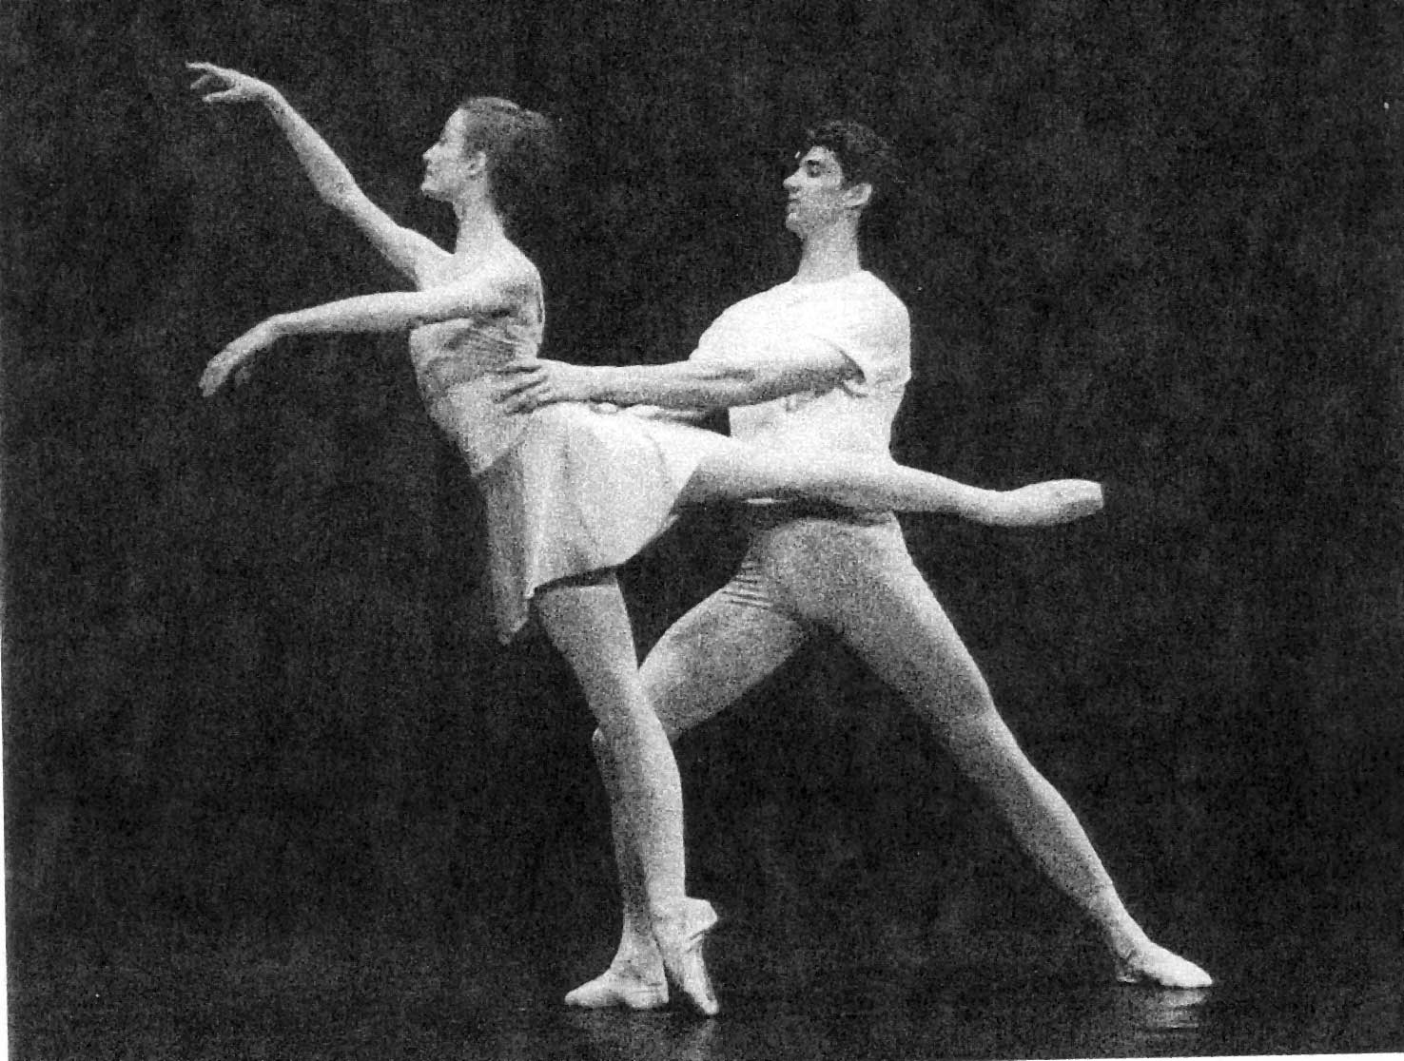
Support
(Floor)
X
Gravity
Friction
Friction
(CG)
Figure 1 Forces acting on the ballerina when partner holds her. (Photo from Physics and the Art of Dance: Understanding Motion).

An alternative way to view the stability of the dancers’ pose is to consider the two dancers as a single unit, imagining them as a statue carved from a single block. Taken as a unit, their center of gravity is probably located at about waist level, roughly half way between the two of them (see Figure 2). Notice that the location of their center of gravity is probably a point in space outside of their bodies, but this is not unusual for objects with complex shapes. The upward support force of the floor is acting at three points, her right toe and his two feet. The net support force can be located anywhere within the “base of support”, which is the geometric area encompassing those three points (see Figure 3). When the center of gravity is located anywhere above the base of support, as it is in this case, then the support force can balance the force of gravity and the pose is stable.

Support
(Floor)
X
Gravity
(CG)
Support
(Floor)
Support
(Floor)
Figure 2: Vertical forces on a pair of dancers considered as a single physical object.

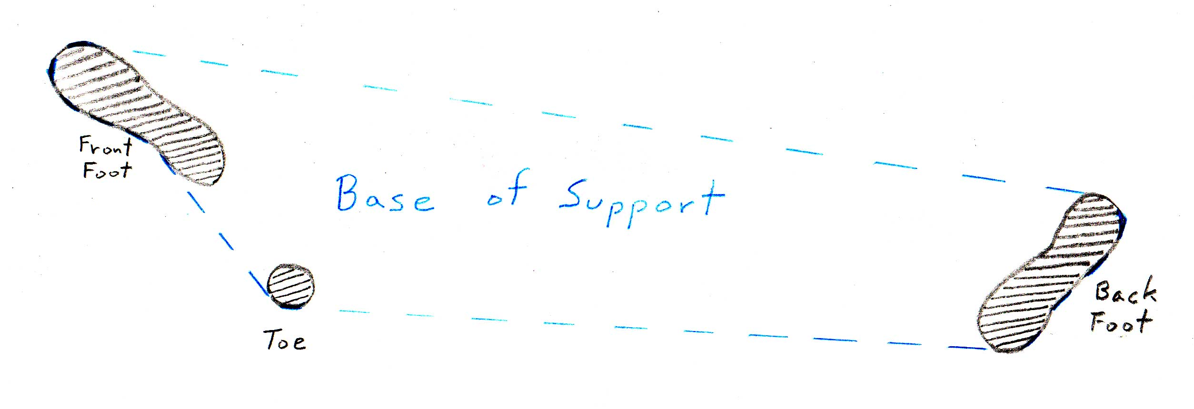
Figure 3: Base of support formed by the man’s feet and ballerina’s toe.
Now suppose the man placed his right (forward) foot further back? Could the dancers lose their balance? Yes, they could if by repositioning his foot he decreased the size of their base of support such that their center of gravity was no longer located somewhere above that base. That is, if the center of gravity is located forward of her right toe, as indicated in Figure 2, then he needs to keep his right foot in front of her toe.

What about his left leg, why is it placed so far back behind him? Could he bring it forward without affecting the balance? Bringing his left foot forward not only decreases the base of support but also changes the dancers’ center of gravity. If he were to place his left (back) foot next to his right foot then not only would their base of support be quite small but their center of gravity would shift significantly forward. If this shift places the center of gravity outside of the base of support then they lose balance. Should the artistic director insists that he place his feet together, then he’ll have to lean backwards in order to return their center of gravity back over the (now much smaller) base of support.

Next time you watch ballet think about how much physics is involved in even a simple pose. Some may think that such an analysis could detract from appreciating the dance but that’s not the case. You’ll never meet an astronomer who doesn’t appreciate the beauty of the moon and stars. Things are just as beautiful when you understand them.

References
Physics and the Art of Dance: Understanding Movement, Kenneth Laws, Oxford University Press (2002) Chapter 6, The Pas de Deux
Conceptual Physics , Paul G. Hewitt, Addison Wesley (2005) Chapter 10, Rotational Motion

To hold this exact pose her center of gravity would need to be located somewhere above her toe, such as in the center of her left thigh, which is unlikely unless she had lead weights in her left shoe!

